**Ideation Phase**

**Define the Problem Statements**

|  |  |
| --- | --- |
| Date | 12 Oct. 22 |
| Team ID | PNT2022TMID18041 |
| Project Name | Hazardous Area Monitoring for Industrial Plant Powered by IoT |
| Maximum Marks | 2 Marks |

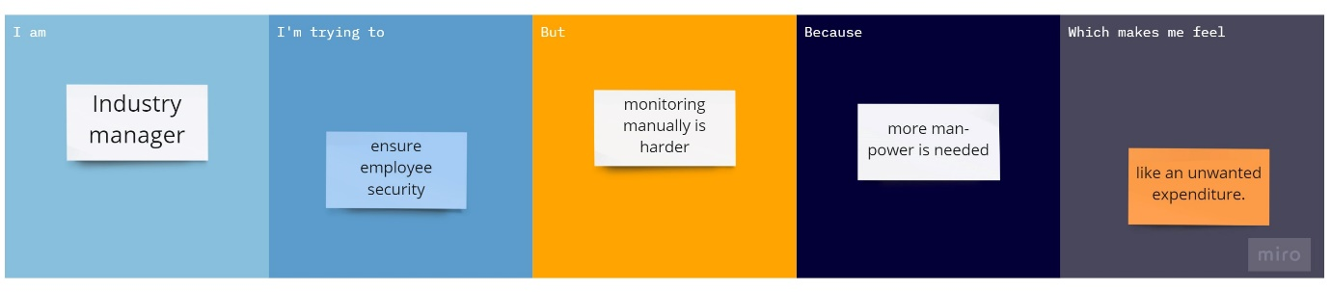

|  |  |  |
| --- | --- | --- |
| I am | Industry manager | Manager who has to keep the employee and the industry safe |
| I’m trying to | Ensure employee security | I try to keep the employees safe from industrial hazards |
| But | Monitoring manually is harder | I have to keep track of the industry environment conditions all the time |
| Because | More manual labour is needed | More employees are needed just to measure the conditions of the industry |
| Which makes me feel | Like an unwanted expenditure | Spending money on employees just to measure conditions is an unwanted expenditure on the company. |